Product Upgrade Description

**Models: WT 145RJOD**

Description

1.1 Surge protector designed to provide protection for Power over Ethernet (POE) enabled devices against

transient surge and static discharge.

* CAT5e, CAT5 (POE5-48-OD) and CAT6 (POE6-48-OD) compatible
* 802.3af
* 10/100/1000 Base-T Gigabit Ethernet protection
* LAN, FDDI, CDDI, ATM,WLAN
* PDH, SDH, SPDH
* Industrial control
* For outdoor use

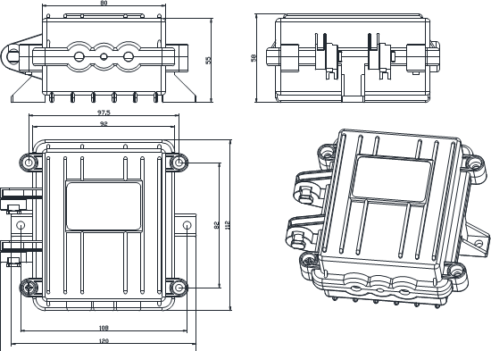

Alteration/improvement from the original models:

* 1. Enclosure size is two fifths times of the original and the weight is three fifths times of the former .
  2. Caps are replaced by simpler entry Installation and wire/cable connection are much easier for user.
  3. Circuit board improved and enhanced.

